Australian governments need to rethink ban on commercial surrogacy
Date: August 4, 2014

Rachel Browne, Alexandra Back
Australian governments need to rethink bans on commercial surrogacy, experts have said after reports that an Australian couple abandoned a baby boy in Thailand.
Laws making commercial surrogacy illegal in some Australian states and territories have led to a boom in couples seeking surrogate mothers overseas, particularly in Thailand and India.
"It’s an absurdity to suggest these bans will stop Australians from going overseas. It’s better that we do it here and regulate it,’’ said Stephen Page, a surrogacy lawyer with Harrington Family Lawyers in Brisbane.
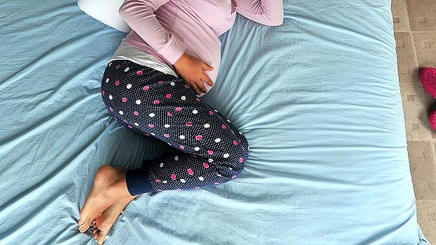
Calls for change to surrogacy laws: Fears that bans encourage couples to go overseas. Photo: Joe Armao
University of Technology, Sydney professor Jenni Millbank supported the call for strictly controlled commercial surrogacy to be permitted in Australia. ‘‘Australians are exporting their reproductive problems overseas,’’ she said. ‘‘We could take a regulated approach here, which allows for some form of compensation.’’
The federal government said it was concerned by baby Gammy's case but it has assigned responsibility for commercial surrogacy laws to the states and territories.
It is illegal in NSW, the ACT and Queensland for a resident to pay a woman overseas to be a surrogate mother. Commercial surrogacy is criminalised in all other states and territories, except the Northern Territory, which does not regulate the practice.
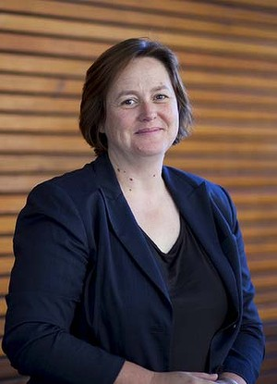
"Australians are exporting their reproductive problems overseas": Jenni Millbank. Photo: Supplied
Surrogacy Australia executive officer Rachel Kunde said the state-based surrogacy laws were a mess, and she urged the federal government to intervene to prevent more cases like Gammy’s.
‘‘Every state has different laws and every law is different,’’ she said. ‘‘Intended parents say it’s all too hard, so why not go overseas, hire an agent to organise everything for so you and you just have to sign on the dotted line. But not every agency is reputable, and that’s where issues such as what we have seen with baby Gammy can arise.’’
Commercial surrogacy in Thailand can cost up to $80,000. In Australia, where women can be altruistic surrogates, costs range between $20,000 and $60,000.
The shortage of surrogate mothers in Australia is driving the growth in overseas surrogacy. Surrogacy Australia estimates that more than 500 Australian babies were born to overseas surrogate mothers every year.
The Family Law Council examined the question of commercial surrogacy in a report handed to Attorney-General George Brandis in last December last year. It did not consider commercial surrogacy laws, since such laws fall within the jurisdiction of the states and territories.
The Attorney-General's department says the government is considering the report and examining the issues in consultation with authorities in Thailand.
Gammy was one of a set of twins born to a surrogate mother in Thailand. The woman who gave birth to him said his Australian biological parents abandoned him and took only his sister when they found out he had Down syndrome and a congenital heart defect.

Read more: http://www.smh.com.au/national/australian-governments-need-to-rethink-ban-on-commercial-surrogacy-20140804-100dmt.html#ixzz3FvZDO5wL

